HOME PAGE:
- Fix the alignment of field on error
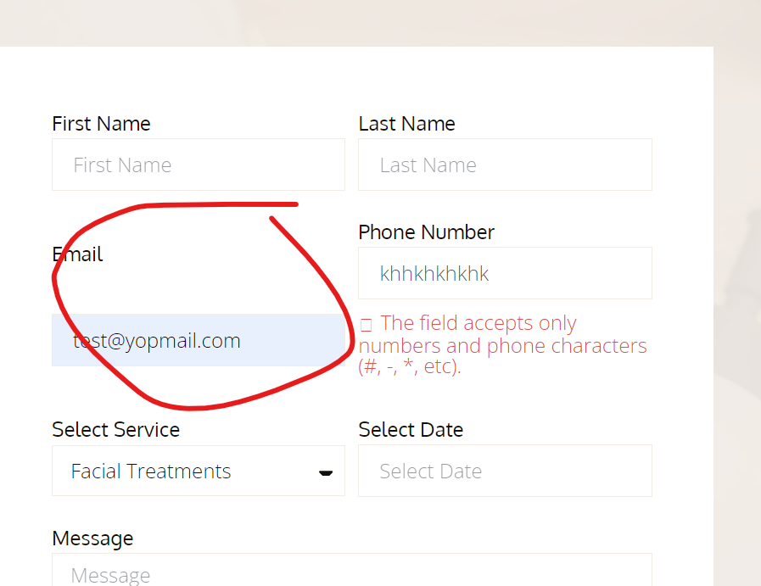

- Add validation on form, form is submitting without input first name, last name, select service, select date and message fields
- Fix the icon
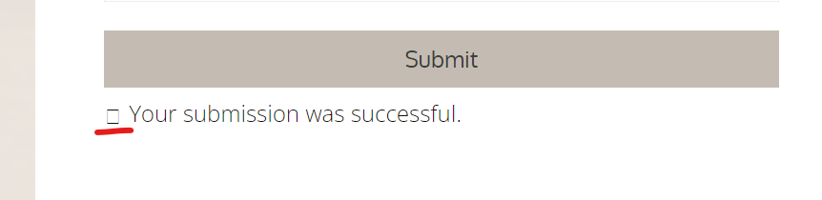
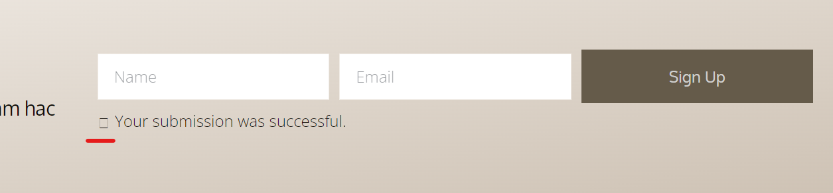

- Add validation on newsletter its submitting without name field
- Link email and phone number
